

Inorganic Materials in Technical Textile Applications
Kaolhinn Jumppanen-Allen, Nawanga Udawaththage and Georgina Delgado Alís

April 2026

Textile and Material Engineering

ABSTRACT
Tampereen ammattikorkeakoulu
Tampere University of Applied Sciences
Textile and Material Engineering
Smart and High-Performance Materials

JUMPPANEN-ALLEN, KAOLHINN 1; UDAWATHTHAGE NAWANGA 2 & DELGADO ALIS, GEORGINA 3:
Inorganic Materials in Technical Textile Applications

Bachelor's thesis 33 pages, appendices 1 page
April 2026
The focus of this report is the role of Inorganic Materials used within the Technical Textile field. Inorganic materials discussed include Metal, Glass, Ceramic, Carbon, and Mineral fibre types. The theoretical analysis addresses structural, performance and sustainability issues. The materials are crucial for use in extreme conditions of high temperature, high strength and high chemical exposure. This report includes two case scenarios, the first one is the use of Inorganic Compounds Coatings as Fire Retardant finishes, and the second case scenario is the Use of Antimicrobial Textiles. This report shows how the use of Inorganic Materials increases safety, durability, and functionality for technical textiles.

Key words: please use lower case initial letters

USE OF AI IN THESIS

I have used AI tools in my thesis:

☐ No
☒ Yes

The AI tools used in my thesis and the purpose of their use has been described below:

Names of the tools and versions: [Chat GPT]

Purpose of the use: [Help in finding articles]

Parts in which AI was used: [2.3,2.5]

I am aware that I am totally responsible for the entire content of the thesis, including the parts generated by AI, and accept the responsibility for any violations of the ethical standards of publications.

CONTENTS
USE OF AI IN THESIS 2
1 INTRODUCTION 4
2 Theory 5
2.1. Metal Fibres 6
2.2. Glass Fibres 6
2.3. Ceramic Fibres 7
2.4. Carbon Fibres 7
2.5. Mineral Fibres 8
3 Inorganic Fire-Retardant Textile Coatings 8
3.1. Silicon Dioxide Coating 9
3.2. Magnesium Hydroxide Coating 11
3.3. Titanium Coatings 14
3.4. Limitations of Inorganic Fire-Retardant Coatings 17
4 Antimicrobial textiles. 18
4.1. Introduction 19
4.2. Inorganic antimicrobial agents. 19
4.2.1 Silver Coatings. 19
4.2.2 Zinc Oxide 21
4.2.3 Copper Oxide 23
4.3. Sustainability of Antimicrobial textiles. 24
5 DISCUSSION 25
6 REFERENCES 26
SFS EN ISO 11612:2015:en. 2015. Protective clothing. Clothing to protect against heat and flame. Minimum performance requirements. Accessed on 24.04.2026. Requires access right. https://online.sfs.fi/fi/index/tuotteet/SFS/CENISO/ID2/1/397610.html.stx 26
Gabbay, J., Borkow, G., Mishal, J., Magen, E. & Zatcoff, R. 2006. Copper oxide impregnated textiles with potent biocidal activities. Journal of Industrial Textiles, 35(4), 323–335. Read 24.4.2026. https://www.researchgate.net/publication/249776996 26
Hasan, M. 2018. Production of antimicrobial textiles by using copper oxide nanoparticles. International Journal of Current Research and Review. Read 26.4.2026. https://www.researchgate.net/publication/326917521 26
Jain, A., Singh, M., Dubey, A. et al. 2022. Development of wash-durable antimicrobial cotton fabrics by in situ green synthesis of silver nanoparticles. Antibiotics, 11(7), 864. Read 26.4.2026. https://pmc.ncbi.nlm.nih.gov/articles/PMC9311951/ 26
Rode, C., Hansmann, F., Bege, N. et al. 2015. Antibacterial zinc oxide nanoparticle coating of polyester fabrics. Journal of Textile Science and Technology, 1, 65–74. Read 24.4.2026. https://www.researchgate.net/publication/281106912 26
Tania, I.S., Ali, M., Hossain, M.S. et al. 2021. Coating of ZnO nanoparticle on cotton fabric to create a functional textile with enhanced mechanical properties. Polymers, 13(16), 2701. Read 26.4.2026. https://www.mdpi.com/2073-4360/13/16/2701 26
Zhang, D., Chen, L., Zang, C. et al. 2013. Antibacterial cotton fabric grafted with silver nanoparticles and its excellent laundering durability. Carbohydrate Polymers, 92(2), 2088–2094. Read 25.4.2026. https://www.sciencedirect.com/science/article/abs/pii/S0144861712012167 26
7 APPENDICES 26

INTRODUCTION

Inorganic materials are materials include minerals, metals and ceramics. Inorganic materials are defined as chemical compounds that contain no carbon-hydrogen bonds, making them have a greater resistance to thermal instability and chemical deterioration. (C.Ripp, M.Borck 2009) Because of their resistance to thermal and chemical deterioration, inorganic materials are preferred in engineering and industrial applications.

Technical textiles are textile materials that are made to serve a functional purpose, meaning technical textiles serve a greater purpose than basic clothing requirements. Technical textiles can be used in the construction industry, automobile industry, healthcare (medical garments) and protective clothing. Technical textiles are engineered to meet specific requirements like heat and chemical resistance, mechanical strength and high durability. (S. Amasamani n.d)

This report talks about the role of inorganic materials in the technical textile industry discussing how technical textile applications are applied and the role inorganic materials provide within said applications. Two case studies focusing on inorganic materials used in fire retardant coatings and antimicrobial textiles will be discussed to demonstrate the benefits of inorganic materials in technical textile applications.

Theory

Metal Fibres

Metal fibres are derived from metals, including stainless steel, aluminium and copper. These are useful for technical textiles, where electrical conductivity, heat resistance and high durability are required. (De Boris Mahltig, Yordan Kyosev 2018, 219)

A key property of metal fibres is their high electrical conductivity. This means metal fibres can be applied in electromagnetic shielding and smart textiles. Another exceptional property is their ability to conduct heat, making metal fibres desirable within high temperature environments. Additionally, these fibres have high tensile and compression strength, consequently being used in reinforcing applications and industrial uses. (M. Miraftab 2016)

From the perspective of sustainability metal fibres have a positive impact as they can be recycled. Metals can be recycled an infinite number of times without a change in the quality of the metal. This leads to essentially no waste of the material. The problems associated with metal fibres arise from the reprocessing of the metal fibres. This can be very energy and resource intensive having a negative impact on the environment due to the emissions and the resources that are used in the process. This is why recycling as well as proper and efficient production methods are important to improve the sustainability of metal fibres. (Gajanan Bhat 2011)

Glass Fibres

In technical textile engineering, glass fibres are highly used inorganic fibres. They are used in composite, insulation and reinforcement applications. They are made from silica-based materials and have a high strength to weigh ratio alongside high chemical and thermal resistance. (Vivek Mane, Chetana Markad 2015).

The primary benefit of glass fibres is their reinforcement ability whilst being lightweight. Glass fibres are also highly resistant to moisture, chemicals and corrosion, making it useful in harsh environments like marine and construction industries. In addition, glass fibres have thermal and electrical insulation properties further emphasising their versatility.

In terms of sustainability, glass fibres can be produced using several different raw materials, the most abundant being sand. This shows that there is a great resource efficiency in the production of glass fibres. Glass fibres can be recycled which adds to the resource efficiency. This does come at the cost of requiring a lot of energy, but the longevity of glass fibres even with the energy cost helps to reduce the impact on the environment. (Pickering, 2006)

Ceramic Fibres

Ceramic fibres are effective in extreme temperature environments in technical textiles used in the aerospace industry, fire protection, and industrial insulation. Because ceramic fibres provide protection at extreme temperatures, they are used in textiles that will be exposed to sustained temperatures greater than 1000°C. (M. Miraftab 2016) Most ceramic fibres are made of alumina and silica.

A great advantage of ceramic fibres is their thermal stability, allowing these to keep an exceptional structural integrity under high heat. Because of their low thermal conductivity, they are effective as insulating materials. Synthetic ceramic fibres also are chemically stable and will not break down in extreme environments. (Bhat Gajanan 2017)

Ceramic fibres are not biodegradable, using a high amount on energy while being produced. Thanks to their durability and recyclability it reduces the environmental impact. Ceramic fibres can be recycled throughout mechanical and chemical recycling processes. Recycling of these fibres must be controlled due to high health risks. (Power 2026)

Carbon Fibres

Carbon fibres can be defined as fibres with a carbon content of 90% or above. These fibres are manufactured with materials like polyacrylonitrile (PAN) trough high-temperature carbonization process. Carbon fibre is a material made from thin filaments of carbon atoms bonded together in a crystalline structure, resulting in an exceptional strength to weight ratio, having these properties allows to produce lightweight and strong structures. They show remarkable stiffness, resistance, thermal stability and resistant to corrosion, making them useful in harsh environments. (De Boris Mahltig, Yordan Kyosev 2018, 31).

Carbon fibres are not the most environmentally friendly due to their production requiring a significant amount of energy, which results in a larger initial carbon footprint than other fibres. Recycling them is particularly difficult, although many new technologies are being developed. However, many of them have a long useful life, and are suited to energy saving applications (like lightweight vehicles), which can help to mitigate the carbon footprint and recycling challenges (Daniel Tortorici et.al 2025)

Mineral Fibres

Mineral fibres are produced from minerals, typically nonorganic substances such as rock, slag or glass. These fibres have basalts and asbestos. Nowadays asbestos are banned due to the health risks associated with it, hence, basalt fibres are more used due to their improved safety and performance. (Ajhar Hussain 2023).

Mineral fibres have high tensile strength, good chemical resistance and good thermal/acoustic insulation. Mineral fibres are implemented in protective clothing, industrial textiles, and construction materials, because of their durability and safety. (Ajhar Hussain 2023).

Mineral fibres have advantages in terms of sustainability, because they use natural and available resources. Particularly, basalt fibres can be better in this regard because they are less processed than glass fibres, which can lead to lower energy use. (Ajhar Hussain 2023).

Inorganic Fire-Retardant Textile Coatings

Many current fire-retardant coatings make use of Halogenated chemical compounds which are known for being toxic to both people and the environment. These chemical compounds release toxic chemicals once exposed to a high enough heat, however, are the only compounds which currently can pass benchmark parameters for flame retardant textile coatings. As a potential more sustainable alternative metal oxide textile coatings are being investigated for their ability to work as a fire-retardant coating for not only textiles but other polymer/composite materials. Metal oxides fail to release toxic gases when exposed to heat for long periods of time, making them ideal compared to the currently used halogenated compounds. (Xian-Wei C., Kai X., Jin-Ping G., Wei L., & Guoqiang C. 2023, 1-2). Additionally, silica exhibits a similar reaction to long exposure to high heat. (Alongi J., Ciobanu M., Tata J., Carosio F., & Malucelli G. 2010, 1968).

Silicon Dioxide Coating

Alongi J., Ciobanu M., Tata J., Carosio F., & Malucelli G. (2010) explored the use of a silicon dioxide coating on different compositions of Cotton/PET textile substrates using the sol-gel process. To form the silicon dioxide nanoparticles different ratios of tetraethoxysilane (TEOS) and water were explored. Depending on the concentration of TEOS, different levels of silicon dioxide formed on the textile surface. The sol-gel process first hydrolyses the TEOS and water solution through mixing, then upon further mixing a polycondensation reaction occurs. The now formed gel is then applied to the textile substrate and calcinated ensuring only silicone dioxide particles are present on the textile surface. TEOS and water concentrations were 1:1, 2:1, and 3:1 respectively. The substrate used was a Cotton Polyester mix, where cotton was 0%, 15%, or 35% of the textile substrate composition. Using nanotechnology to improve and preserve durability properties of substrate. (Alongi J., Ciobanu M., Tata J., Carosio F., & Malucelli G. 2010, 1961-1962).

Silicon dioxide film homogeneity on top of the different substrate compositions can be seen in figure 1. Silicone distribution was measured using scanning electron microscopy. All fibres show good distribution of the silicone, meaning the TEOS water ratios did not affect the formation of the silica. However, the higher the ratio the more rigid the textile; microcracks are present on parts a and b. (Alongi J., Ciobanu M., Tata J., Carosio F., & Malucelli G. 2010, 1963-1964).

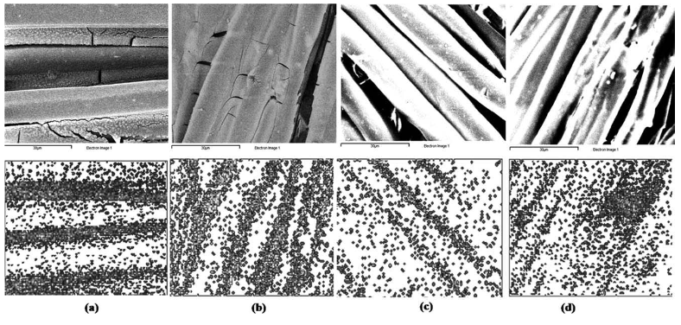
FIGURE 1. Dispersion of silica on tested fibres a) PET, b) cotton, c) cotton 15%, and d) cotton 35% with TEOS 3:1 ratio. (Alongi J., Ciobanu M., Tata J., Carosio F., and Malucelli G. 2010, 1963)

Combustion of PET occurred regardless of the silica presence. However, the substrates where cotton was present improved significantly in its combustion behaviour. The time to ignition (TTI) increased by 93% for the cotton 35% blend with the TEOS ratio 2:1 when compared with the untreated textile substrate (see Table 1). This means higher levels of cotton in the substrate and higher levels of silica present on top of the substrate improved combustion properties.

TABLE 1. Fire Resistant testing of different fibre variables. (Alongi J., Ciobanu M., Tata J., Carosio F., and Malucelli G. 2010, 1966). 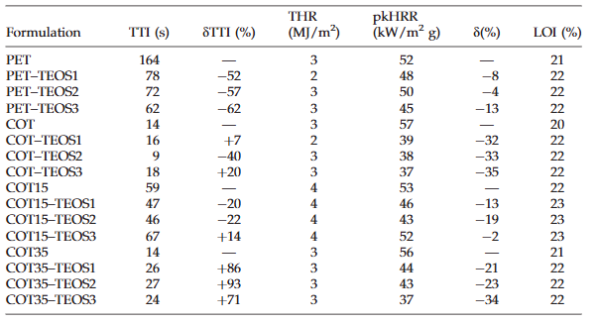

Overall thermal stability improved in both nitrogen and air conditions after sol-gel silica treatment. Combustion behaviour significantly changed due to presence of silica. (1966-1968)

Magnesium Hydroxide Coating

Magnesium hydroxide is currently used in epoxy resin, ethylene vinyl acetate, and polyvinyl composites. Whilst most textile research focuses on bio-based fire-retardants which form a char barrier on the textile ’choking’ the flame, magnesium oxide could potentially work better as it dilutes the flame and turns the flame into water vapor whilst also forming a barrier from the flame due to the presence of magnesium oxide. However, insufficient adhesion of magnesium hydroxide to textile substrates has posed a large issue preventing the use of magnesium hydroxide coatings as textile fire retardant coatings. (Xian-Wei C., Kai X., Jin-Ping G., Wei L., & Guoqiang C. 2023, 2).

Xian-Wei C., Kai X., Jin-Ping G., Wei L., & Guoqiang C. (2023) sought to solve this issue by using a coating made of magnesium hydroxide nanoparticles alongside a silane coupling agent to improve magnesium hydroxide adhesion to silk textiles. The silane acts as a cross linker of magnesium oxide nanoparticles and silk textile. Silk textiles were coated with 15g/L (Silk@MH-15) or 30g/L (Silk@MH-30) silane-modified Mg(OH)₂. Testing was performed on the adhesion and durability of the magnesium hydroxide coating on the textile after washing (see figure 2).

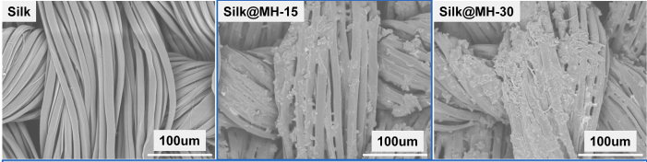
FIGURE 2. Microscopic analysis of particle distribution on silk textile (Xian-Wei C., Kai X., Jin-Ping G., Wei L., & Guoqiang C. 2023, 3).

Figure 2 shows even distribution of the particles along the silk fibres, implying good adhesion to the silk textile. XRD (X-ray diffractor) and FT-IR analysis of the silane modified Mg(OH)₂ nanoparticles revealed that the modifier ethanol solution KH550 did not negatively alter the Mg(OH)₂ nanoparticles. XRD analyses showed explainable differences between modified and unmodified Mg(OH)₂ nanoparticles. As the concentration of nanoparticles increased, tensile strength decreased. Higher concentrations of nanoparticles also increased the flexural rigidity of the textile. (Xian-Wei C., Kai X., Jin-Ping G., Wei L., & Guoqiang C. 2023, 4-5).

Whilst the textile started to degrade at a lower temperature than the treated textile, the textile lost less mass and took longer to degrade (see table 2). Testing followed the ASTM D7309-26 method of thermal degradation in an oxygen-free environment, meaning the textile underwent pyrolysis instead of total combustion (ASTM D7309-26, 2). T10% and T50% refer to the temperature recorded upon 10% and 50% decomposition of the textile, respectively. The last column records the final mass recorded at 700°C.

TABLE 2. Thermal degradation in Nitrogen atmosphere. (Xian-Wei C., Kai X., Jin-Ping G., Wei L., & Guoqiang C. 2023, 5).
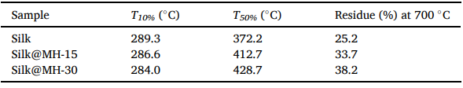

Xian-Wei C., Kai X., Jin-Ping G., Wei L., & Guoqiang C. (2023) say once decomposition started occurring, the Mg(OH)₂ nanoparticles released water molecules dissipating the flame, allowing for magnesium oxide and silica networks to form, essentially ‘shielding’ the textile from fast decomposition. (Xian-Wei C., Kai X., Jin-Ping G., Wei L., & Guoqiang C. 2023, 5).

Additionally, a reduction in smoke release, peak heat release, and total heat release rates showed significant reductions (see appendix 1). This means the fire burned at a slower less intense rate and less smoke was emitted than the untreated silk textile. (Xian-Wei C., Kai X., Jin-Ping G., Wei L., & Guoqiang C. 2023, 5-6).

The silk textile passed B1 flame retardant classification upon vertical burn testing after undergoing 15 robust washing cycles. B1 classification was determined by the GB/T 17591–2006 standard. When the silk textile was tested after 20 wash cycles, it failed to meet B1 classification. As seen in Picture 1, the Mg(OH)₂ coated textile could extinguish the flame, but char lengths increased as the textile was washed more. Limited oxygen index (LOI) values were also tested. The untreated textile had an LOI of 23.6%. After application of the Silk@MH-15 and Silk@MH-30 coatings the LOI increased to 31.5% and 32.2% respectively (Xian-Wei C., Kai X., Jin-Ping G., Wei L., & Guoqiang C. 2023, 6).

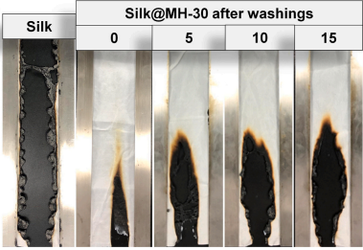
PICTURE 1. Silk@MH-30 vertical burn testing after wash cycles. (Xian-Wei C., Kai X., Jin-Ping G., Wei L., & Guoqiang C. 2023, 7).

For a textile to be combustible in air the LOI value should be 21% or lower (HAVEP 2026). This means the treated silk textiles saw a desirable increase in LOI values.

Titanium Coatings

Titanium dioxide coatings are usually used in self-cleaning film applications. Usually the sol-gel process requires extreme heat conditions in the calcination stage of the process. The high heat temperatures can be problematic when trying to impart titanium nanoparticles onto a textile substrate; titanium is sensitive to high heat conditions. For this reason, Hadi Fallah M., Abdollah Fallah S., and Mohammad Ali Z. (2011) used lower temperatures than usual (500ºC and 700ºC) for calcination in this experiment. The aim was to test cotton fabrics and their ability to self-clean and resist flame after the application of Titanium dioxide using the modified sol-gel process. (Hadi Fallah M., Abdollah Fallah S., and Mohammad Ali Z. 2011, 717-718).

As seen in table 3, both treated samples were able to stop a flame from further propagating up the textile strip.

TABLE 3. Vertical burning test of cellulose fabric with and without sol-gel treatment. (Hadi Fallah M., Abdollah Fallah S., and Mohammad Ali Z. 2011, 718).
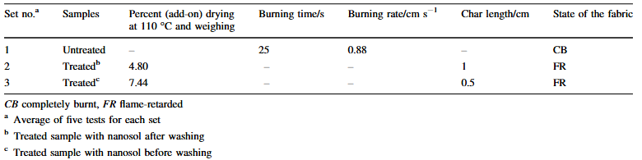

The untreated textile burned completely. Additionally, the higher the titanium concentration on the textile the smaller the char length (Hadi Fallah M., Abdollah Fallah S., and Mohammad Ali Z. 2011, 720-721).

Upon sustained high heat exposure in air, the treated cellulose textile starts degrading at a lower temperature than the untreated cellulose textile (see figure 3). Even though the treated textile starts degrading at a lower temperature, it degrades at a much slower rate than the untreated textile.

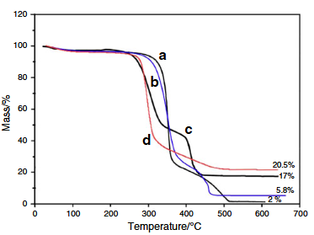
FIGURE 3. Combustion curves of untreated and treated cellulose textile. Consists of a) Untreated textile in air, b) untreated textile in nitrogen, c) treated textile in air, and d) treated textile in nitrogen. (Hadi Fallah M., Abdollah Fallah S., and Mohammad Ali Z. 2011, 721).

Additionally, when tested under nitrogen conditions, the textile started degrading at a lower temperature, but again at a slower rate. The treated cellulose textile in nitrogenic conditions also lost the least amount of mass compared to other variables (Hadi Fallah M., Abdollah Fallah S., and Mohammad Ali Z. 2011, 721-722).

Alternatively, Malek E., Miedzinska D., and Stankiewiecz M., (2017) sought to create a fireproof textile coated with titanium silicide. Two textile substrates were tested. The textile substrate, Proton, consisted of Para amide 58%, PBI 40%, and an antistatic coating 2%. The other textile substrate, Natan, consisted of Nomex 75%, Kevlar 23%, and P140 (carbon fibre) 2%. (Malek E., Miedzinska D., and Stankiewiecz M. 2017, 510- 511)

The treated proton textile radiated at a significantly lower temperature compared to the untreated textile after being subjected to 330ºC. Similarly, at 60ºC and 100ºC the treated textile performed better. The treated Natan textile also exhibited similar results; however, results were less discernable than the treated Proto n textile (See figure 4). (Malek E., Miedzinska D., and Stankiewiecz M. 2017, 513-514).

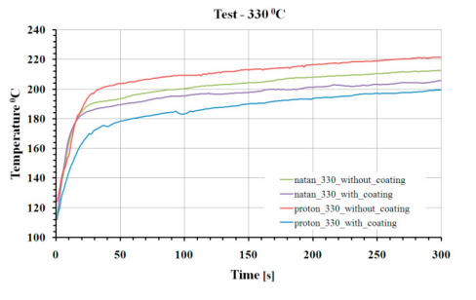
FIGURE 4. Heat radiation of different textile variables. (Malek E., Miedzinska D., and Stankiewiecz M. 2017, 514)

Heat differences between the treated and untreated textiles were small at temperatures 60ºC and 100ºC. However, significant differences in temperature between the treated and untreated textiles occurred at 330ºC. Temperature differences were as follows: 20ºC for the Proton textile and 10ºC for the Natan textile. (Malek E., Miedzinska D., and Stankiewiecz M. 2017, 515).

Limitations of Inorganic Fire-Retardant Coatings

All mentioned inorganic coatings require mining to obtain the raw materials needed. Materials needed to be mined are magnesite (Magnesium King, 2025), titanium and silica (O.A. Fouad, M. Yamazato, A. Hiroshi, M. Era, M. Nagano. 2003). Mining causes high consumption of water, high consumption of fossil fuels, pollution, etc (UNEP 2024, 2). Most CO2 emissions occur in processing stages of mining where high heats are generally used (UNEP 2024). Additionally, depending on the mine, more sustainable or unsustainable practices are performed. For example, one mining operation may be dumping wastewater into fresh water sources damaging the environment (Mining Watch Canada 2012). Many profit focused mines do this to reduce costs in wastewater management (Tian G. and Huang J. 2025). Whilst these alternative inorganic fire-retardant coatings can potentially outperform and are less toxic than halogenated fire-retardant coatings, careless overproduction of inorganic textile coatings in future may exacerbate extraction related sustainability issues.

Fire-retardant technical textiles are required by the European Union to achieve certain criteria for safety of personal protective equipment (European Union 1989). The standard SFS EN ISO 11612:2015:en (2015, 27) contains testing guidelines of fire-retardant textiles in line with European regulations. One of the criteria describes the ageing of extended use fire retardant textiles upon finished textile production (SFS EN ISO 11612:2015:en 2015, 13). As mentioned by Xian-Wei C., Kai X., Jin-Ping G., Wei L., & Guoqiang C. (2023), one of the biggest problems with inorganic oxides used as coatings for textiles is the adhesion of the oxides onto the textile. Xian Wei (2023) was able to significantly improve the textile’s adhesion to magnesium oxide using silane, but after 20 washes the fire retardant was no longer able to pass GB/T 17591–2006 B1 classification. Additionally, a silicon dioxide coating imparted cracks onto the fibre surface of the cotton/PET textile substrates, as mentioned by Alongi J., Ciobanu M., Tata J., Carosio F., and Malucelli G. (2010, 1963). Microcracks impact the mechanical durability of a textile, meaning, the stress/strain and elasticity moduli of the fibre was likely reduced upon application of the oxide coating. Xian-Wei C., Kai X., Jin-Ping G., Wei L., & Guoqiang C. (2023, 5) also mentioned application of the inorganic fire-retardant coating resulted in lower tensile strength and higher material rigidity. If these textiles are to be used in long-term technical textile applications, such as workwear, the coatings need to be durable upon use (SFS EN ISO 11612:2015:en 2015). Other mentioned studies did not test for flame-retardant coating effect on tensile performance nor fire resistance performance after several wash cycles further emphasising the need for wash testing in future studies.

Antimicrobial textiles.

Introduction

Antimicrobial textiles are fabrics that are treated to reduce or stop the growth of microorganisms such as bacteria, fungi and viruses. These textiles are important because normal fabrics can collect moisture, sweat, skin cells and dirt, which can support microbial growth. This is especially important in hospitals, wound dressings, sportswear, uniforms, protective clothing and public-use textiles. Nanoparticle coatings are one of the most researched methods for producing antimicrobial textiles. Silver nanoparticles, copper oxide nanoparticles and zinc oxide nanoparticles are commonly studied because they can be applied to textile fibres and give the fabric extra functions, such as antibacterial activity, antiviral activity, UV protection or improved hygiene. Recent studies show that antimicrobial textile coatings are usually applied using methods such as pad-dry-cure, in situ synthesis, dip coating, ultrasonic coating and atomic layer deposition. These methods are used because they can attach active particles to the textile surface without completely changing the base fabric.

Inorganic antimicrobial agents.

Silver Coatings.

Silver is one of the most common antimicrobial agents used in textiles. Silver nanoparticles are popular because they have a large surface area and can release silver ions slowly. These silver ions can damage bacterial cell membranes, affect enzymes and proteins, and interfere with DNA replication. This makes silver effective against both Gram-positive and Gram-negative bacteria. Two types of bacteria are tested in reference to antimicrobial activity to confirm that the antimicrobial agent would affect bacteria with different types of cell membranes.

A study by Jain et al. (2022) investigated silver nanoparticle coating on cotton fabric using an in situ green synthesis method. Silver nitrate was reduced using Azadirachta indica (neem) leaf extract, which allowed nanoparticles to form directly on the fiber surface. The researchers also used mercerization and hydrothermal treatment (120 °C, 15 psi) to improve bonding between the nanoparticles and the cotton fibers.

The results (see figure X) showed that the treated fabric had strong antibacterial activity against drug-resistant bacteria, including Escherichia coli and Staphylococcus aureus. In addition, the fabric maintained significant antibacterial performance even after multiple washing cycles, demonstrating improved wash durability compared with untreated or weakly coated fabrics (Jain et al. 2022).

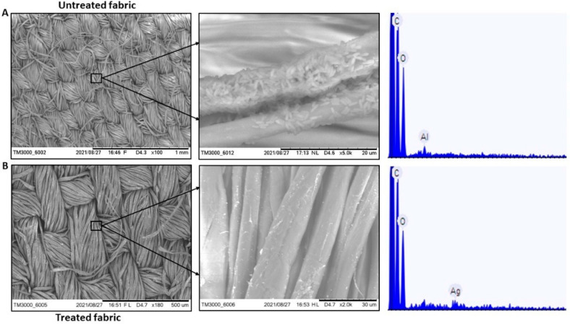
Picture X. SEM images (A) untreated fabric showing bacterial colonization and absence of Ag on the surface (B). Treated fabric showing no bacterial colonization and presence of Ag nanoparticles on the surface (Jain et al., 2022)

Additionally, Zhang et al., (2013) examined silver nanoparticles grafted onto oxidized cotton fabric. The oxidized process created functional groups on the cotton surface, which allowed stronger bonding of the nanoparticles. The results showed that the coated fabric had excellent antibacterial efficiency, with near-complete inhibition of S. aureus and E. coli. More importantly, the antibacterial activity remained high even after repeated laundering cycles, showing significantly improved durability compared with conventional coating methods (Zhang et al. 2013).

Silver coatings are highly effective and widely used in medical textiles, wound dressings and hygiene products. Their main advantage is strong antimicrobial activity at low concentrations. However, silver is expensive compared with other materials, and silver nanoparticles can leach into wastewater during washing. This can cause environmental concerns because silver ions are toxic to aquatic organisms. Therefore, current research focuses on improving durability and reducing silver release (Jain et al. 2022; Zhang et al. 2013).

Zinc Oxide

Zinc oxide (ZnO) is another important inorganic antimicrobial agent often seen as a more affordable and multifunctional alternative to silver. Giedraitienė et al. (2024) focused on cotton textiles that were coated with ZnO nanoparticles. In this study, the researchers used a combination of green synthesis methods and low-temperature oxygen plasma treatment to apply the coating.

The antimicrobial performance of the ZnO-coated textiles was tested against Escherichia coli, Staphylococcus aureus, and Candida albicans. The results showed strong antibacterial activity, especially against Gram-negative bacteria, and showed antifungal activity, with about 52% inhibition of Candida albicans. Scanning electron microscopy to observe the microorganisms after exposure to the textile, and they found clear signs of cell damage, such as disrupted cell walls and deformed structures. ZnO works through several mechanisms at the same time. One of the main mechanisms is the formation of reactive oxygen species (ROS), which can damage proteins, lipids, and DNA inside microbial cells. In addition to this, ZnO can release zinc ions, which interfere with microbial metabolism, and can interact with the cell membrane, causing physical damage. (Giedraitienė et al., 2024).

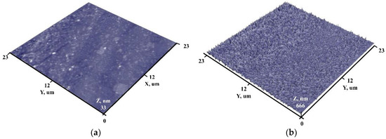

Picture 2. Surface views of initial surface (a) and with ZnO nanoparticles (b) . (Giedraitienė et al., 2024).

Tania et al. (2021) studied ZnO nanoparticle coatings on cotton fabric and evaluated both antimicrobial and mechanical properties. The results showed that ZnO-coated fabrics had improved antibacterial performance, but also experienced changes in mechanical properties such as increased stiffness and reduced flexibility. The study found that using binders could improve coating stability and maintain better fabric performance (Tania et al. 2021).

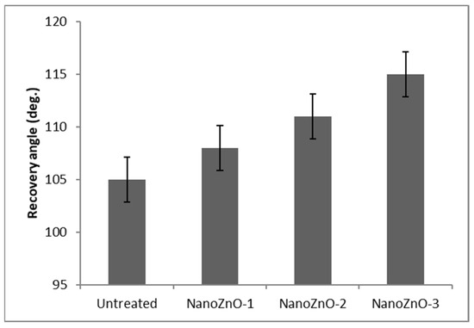
Figure X. Crease recovery of untreated and ZnO nano-treated fabric. (Tania et al,. 2021)

The results show that ZnO nanoparticle coating improves the crease recovery of cotton fabric. The untreated fabric had a recovery angle of 105°, while coated samples showed gradual improvement, with NanoZnO-1 increasing by about 3%, NanoZnO-2 by 5.7%, and NanoZnO-3 achieving around 10% improvement. This improvement is due to ZnO nanoparticles filling fabric pores and being fixed by binders, while emulsions reduce the effect of hydroxyl groups in cotton, making the fabric less prone to wrinkling. Overall, higher ZnO concentration leads to better crease resistance and improved easy-care properties. This case study is important because it considers real textile usability, not only antimicrobial effectiveness.

Copper Oxide

Copper oxide nanoparticles are used because copper ions can damage microbial cells through membrane disruption, oxidative stress, protein damage and DNA interference. To research this, Hasan (2018) studied cotton fabric coated with copper oxide nanoparticles using the pad-dry-cure method, which is commonly used in textile finishing. The antimicrobial performance was tested using agar diffusion and bacterial reduction methods. The results showed that the treated cotton fabric had clear antibacterial activity against tested bacteria, with visible inhibition zones and significant reduction in bacterial growth compared to untreated cotton. This confirmed that CuO nanoparticles can effectively enhance the antimicrobial properties of cotton textiles (Hasan 2018).

Gabbay et al. (2006) investigated cotton and polyester fabrics that were impregnated with copper oxide particles. The researchers tested these textiles against a wide range of microorganisms including bacteria, fungi, viruses, and even dust mites. Impregnation of copper into the polyester and cotton fabrics was achieved by adding cupric oxide powder to the polymers.

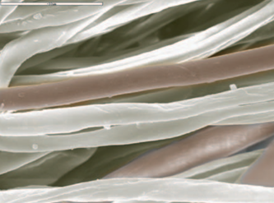
FIGURE X. Mixture of cotton copper oxide plated fibers and untreated fibers as
observed by SEM (Gabbay et al,. 2006)

The study also included real-use examples. For instance, socks containing about 10% copper oxide fibers were shown to reduce symptoms of athlete’s foot (fungal infection), while copper oxide-treated bed sheets resulted in significantly lower bacterial colonization in clinical settings compared to regular sheets (Gabbay et al. 2006).

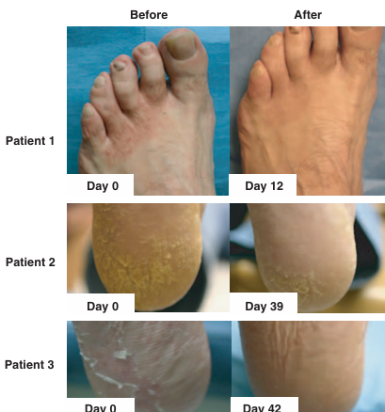
Figure X. Athlete’s foot infection at day 0 and after wearing socks containing 10% copper-impregnated fibers in three patients. (Gabbay et al., 2006)

Another important result was that the coated textiles were found to be safe for human use, with no skin irritation or sensitization reported. This suggests that copper oxide textiles can be used in direct contact with skin, such as in clothing and medical applications (Gabbay et al. 2006). Compared to silver, copper is usually cheaper, which makes it more suitable for large-scale applications like hospital bedding and uniforms. Even though it may not always be as strong as silver, it still provides effective and long-lasting antimicrobial protection (Gabbay et al., 2006).

Sustainability of Antimicrobial textiles.

The sustainability of antimicrobial textile coatings depends mainly on durability, environmental impact and material safety. Studies show that coatings like silver, copper oxide and zinc oxide can provide strong antimicrobial performance, but they also raise concerns about nanoparticle release during washing. For example, Jain et al. (2022) highlighted that even though silver nanoparticle coatings can be made more durable, some silver may still leach into wastewater, which can be harmful to aquatic organisms. In comparison, Gabbay et al. (2006) showed that copper oxide particles can be more strongly embedded into fibres, improving durability and reducing release, which makes them more sustainable in long-term use. Similarly, studies on ZnO coatings (Tania et al. 2021) indicate that durability depends on coating methods and binders, which help reduce environmental impact. Overall, while these coatings improve textile performance, their sustainability depends on balancing antimicrobial effectiveness with long-term durability and minimal environmental release.

DISCUSSION

Inorganic fibres have superior properties, especially in environments of high stress and extreme conditions. Inorganic fibres are often used in advanced engineering applications. Glass fibers and ceramic fibres are great for thermal resistance and thermal insulation, while metal and carbon fibers are good reinforcement fibers and of high functionality with high mechanical strength, high thermal and electrical conducting abilities.

Inorganic materials have a long lifespan and high resistance to degradation due to chemically and thermally properties. This resistance contributes greatly to the extended lifespan of inorganic materials. This extended lifespan offsets the energy costs that are extensive in the materials manufacture.

Despite these advantages, a few limitations were identified. Mechanical performance was negatively affected in some cases. For instance, the silica-coated fibres exhibited surface cracking, where such microcracks may reduce the flexibility and mechanical strength of the textile needed critical for applications requiring repeated movement or bending. Similarly, magnesium hydroxide coatings increased fabric stiffness and reduced tensile strength at higher nanoparticle concentrations, indicating that improvements in flame resistance may come at the expense of comfort and mechanical durability.

Wash durability remains a significant limitation for inorganic coatings. Although the magnesium hydroxide finish maintained B1 flame-retardant classification for 15 wash cycles, performance dropped below the required level after 20 cycles, demonstrating that adhesion between inorganic oxides and textile substrates is still a major challenge. Insufficient adhesion reduces long-term effectiveness, especially for protective textiles that must withstand repeated laundering. Mechanical drawbacks such as increased stiffness or surface microcracking further complicate the use of these coatings in applications where flexibility and durability are essential.
Sustainability concerns also influence the feasibility of inorganic coatings. While inorganic fibres such as metal, glass and basalt offer recyclability and long service life, the raw materials required for coatings such as silica, titanium and magnesite depend on mining processes associated with “high consumption of water, high consumption of fossil fuels, pollution.” Although inorganic coatings are less toxic than halogenated flame retardants, their environmental impact must be evaluated across the entire life cycle. Overall, the results indicate that inorganic materials provide clear performance benefits for technical textiles, but improvements in adhesion, mechanical behaviour and sustainable sourcing are needed before they can fully replace conventional systems.

REFERENCES

ASTM D7309-26. 2007. Standard Test Method for Determining Flammability Characteristics of Plastics and Other Solid Materials Using Microscale Combustion Calorimetry. Read on 21.05.2026. Requires access right. https://compass.astm.org/content-access?contentCode=ASTM%7CD7309-26%7Cen-US

C. Ripp, G. Hambitzer, L. Zinck, M. Borck. 2009 SECONDARY BATTERIES – LITHIUM RECHARGEABLE SYSTEMS – LITHIUM-ION | Inorganic Electrolyte Batteries https://www.sciencedirect.com/topics/chemistry/inorganic-material

S. Amasamani (n.d) Introduction to Technical Textiles.https://ebooks.inflibnet.ac.in/hsp08/chapter/introduction-to-technical-textiles/

Bhat Gajanan. 2017. Structure and Properties of High-Performance Fibers. https://www.researchgate.net/publication/316937052_Structure_and_Properties_of_High-Performance_Fibers

Vivek Mane, Chetana Markad 2015. An overview of glass fibers. https://www.textiletoday.com.bd/an-overview-of-glass-fibers

Tareque Rahaman, Md. Mubashwir Moshwan,2026. Advancements in natural fibers for sustainable textile manufacturing: Importance, sources, applications, and future prospects, Next Materials, Volume 10, https://doi.org/10.1016/j.nxmate.2025.101564

S.J. Pickering. 2006Recycling technologies for thermoset composite materials—current status, Composites Part A: Applied Science and Manufacturing, Volume 37, Issue 8,
https://www.sciencedirect.com/science/article/pii/S1359835X05002101

Power 2026. Can Ceramic Fiber be Recycled? Sustainability Methods, and Industry Insights. https://chinathermalinsulation.com/ceramic-fiber-recycling/

Daniele Tortorici, Yi Chen, Leon Mishnaevsky, Susanna Laurenzi,Recycling 2025 Carbon Fibers by Solvolysis: Effects of porosity and process parameters, Composites Part A: Applied Science and Manufacturing, Volume 190, https://doi.org/10.1016/j.compositesa.2024.108667

Bhatt P, Goe A. Carbon Fibres: Production, Properties and Potential Use. Mat.Sci.Res.India;14(1). Available from: http://www.materialsciencejournal.org/?p=5641

Ajhar Hussain, Samreen, Nuzhat Fatima, 2023 Mineral Fibres in the Textile Industry: A Sustainable Approach. https://juniperpublishers.com/ctftte/pdf/CTFTTE.MS.ID.555749.pdf

Xian-Wei C., Kai X., Jin-Ping G., Wei L., & Guoqiang C. 2023. Construction of silane-modified nanoscale magnesium hydroxide as an inorganic flame-retardant coating for silk textiles. Colloids and Surfaces A: Physicochemical and Engineering Aspects 676, 1-9. https://doi.org/10.1016/j.colsurfa.2023.132287

M. Miraftab,2016 Technical fibres: Recent advances, Handbook of Technical Textiles (Second Edition),Pages 21-41. https://doi.org/10.1016/B978-1-78242-458-1.00002-9.

Alongi J., Ciobanu M., Tata J., Carosio F., & Malucelli G. 2010. Thermal Stability and Flame Retardancy of Polyester, Cotton, and Relative Blend Textile Fabrics Subjected to Sol-Gel Treatments. Journal of Applied Polymer Science 119, 1961-1969. https://doi.org/10.1002/app.32954

Hadi Fallah M., Abdollah Fallah S., & Mohammad Ali Z. 2011. Flame-retardancy and photocatalytic properties of cellulosic fabric coated by nano-sized titanium dioxide. Journal of Thermal Analytical Calorimetry 104 (2), 717-724. https://doi.org/10.1007/s10973-010-1133-x

Malek E., Miedzinska D., and Stankiewiecz M. 2017. Heat resistance research and surface analysis of fireproof textiles with titanium silicide coating. Procedia Structural Integrity 5, 508-515. Doi: 10.1016/j.prostr.2017.07.152.
HAVEP. 2026. What is limiting oxygen index (LOI) and why is it important? Read on 21.04.2026. https://www.havep.com/en/blog/what-limiting-oxygen-index-loi-and-why-it-important

European union. 1989. Council Directive 89/686/EEC of 21 December 1989 on the approximation of the laws of the Member States relating to personal protective equipment. Read on 21.04.2026. https://eur-lex.europa.eu/eli/dir/1989/686/oj/eng.

O.A. Fouad, M. Yamazato, A. Hiroshi, M. Era, M. Nagano. 2003. Formation of titanium silicide thin films on Si(100) substrate by RF plasma CVD. Surface and Coatings Technology 169–170, 632-635. https://doi.org/10.1016/S0257-8972(03)00078-1.

Magnesium King. 2025. How Magnesium Oxide is Made? Read on 21.04.2026. https://www.magnesiumking.com/news/how-magnesium-oxide-is-made.html

UNEP. 2024. Climate Risks in the Metals and Mining Sector. Geneva. Read on 21.04.2026. https://www.unepfi.org/wordpress/wp-content/uploads/2024/05/Climate-Risks-in-the-Metals-and-Mining-Sector-1.pdf

Mining Watch Canada. 2012. Troubled Waters: How Mine Waste Dumping is Poisoning Our Oceans, Rivers and Lakes. Read on 21.04.2026. https://miningwatch.ca/publications/2012/2/28/troubled-waters-how-mine-waste-dumping-poisoning-our-oceans-rivers-and-lakes

Tian G. and Huang J. 2025. Australia wants to be a critical minerals superpower – but processing is messy and dangerous. The Conversation. Read on 21.04.2026. https://theconversation.com/australia-wants-to-be-a-critical-minerals-superpower-but-processing-is-messy-and-dangerous-269799

SFS EN ISO 11612:2015:en. 2015. Protective clothing. Clothing to protect against heat and flame. Minimum performance requirements. Accessed on 24.04.2026. Requires access right. https://online.sfs.fi/fi/index/tuotteet/SFS/CENISO/ID2/1/397610.html.stx

Gabbay, J., Borkow, G., Mishal, J., Magen, E. & Zatcoff, R. 2006. Copper oxide impregnated textiles with potent biocidal activities. Journal of Industrial Textiles, 35(4), 323–335. Read 24.4.2026. https://www.researchgate.net/publication/249776996

Hasan, M. 2018. Production of antimicrobial textiles by using copper oxide nanoparticles. International Journal of Current Research and Review. Read 26.4.2026. https://www.researchgate.net/publication/326917521

Jain, A., Singh, M., Dubey, A. et al. 2022. Development of wash-durable antimicrobial cotton fabrics by in situ green synthesis of silver nanoparticles. Antibiotics, 11(7), 864. Read 26.4.2026. https://pmc.ncbi.nlm.nih.gov/articles/PMC9311951/

Rode, C., Hansmann, F., Bege, N. et al. 2015. Antibacterial zinc oxide nanoparticle coating of polyester fabrics. Journal of Textile Science and Technology, 1, 65–74. Read 24.4.2026. https://www.researchgate.net/publication/281106912

Tania, I.S., Ali, M., Hossain, M.S. et al. 2021. Coating of ZnO nanoparticle on cotton fabric to create a functional textile with enhanced mechanical properties. Polymers, 13(16), 2701. Read 26.4.2026. https://www.mdpi.com/2073-4360/13/16/2701

Zhang, D., Chen, L., Zang, C. et al. 2013. Antibacterial cotton fabric grafted with silver nanoparticles and its excellent laundering durability. Carbohydrate Polymers, 92(2), 2088–2094. Read 25.4.2026. https://www.sciencedirect.com/science/article/abs/pii/S0144861712012167
Gulati, R. 2021. Antimicrobial textiles: recent advances and applications. Read 26.4.2026. https://europepmc.org/article/pmc/pmc8275915

APPENDICES
Appendix 1

